In QIIME open-reference picking, OTUs were picked with the method uclust at a similarity threshold of 0.97. OTUs with less than 5 sequences were discarded. As a result, 18162 OTUs were picked. OTUs were then classified with clust, and 15719 out of 18162 OTUs were classified at phylum level, while 6378 were classified at genus level. 2.16% reads remained unclassified. This may help answer reviewer question 4.

The OTU table was then rarefied to 10,000 reads per sample. Samples with less than 10,000 reads were discarded. Those OTUs absent in more than 75% of the samples were discarded as well. The abundance were then log10(n+1) transformed before analysis. The figures generated with open-reference OTU picking and rarefaction led to similar conclusions as the original ones. This may help answer reviewer questions 11 and 12 about closed-reference OTU picking and normalization.

**Figure** . Multidimensional scaling (MDS) at the OTU level (open-reference OTU picking with QIIME). (#MDS2 is used in panel c here because it shows more separation than MDS1)

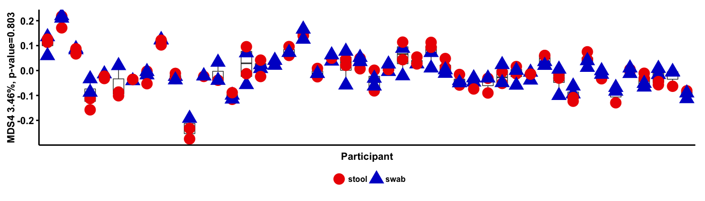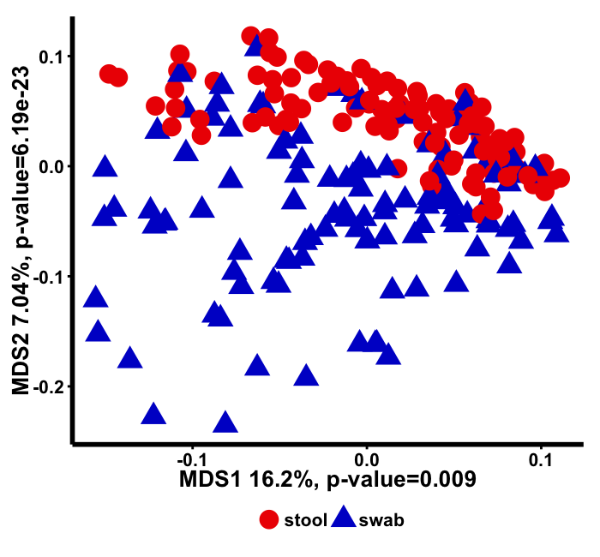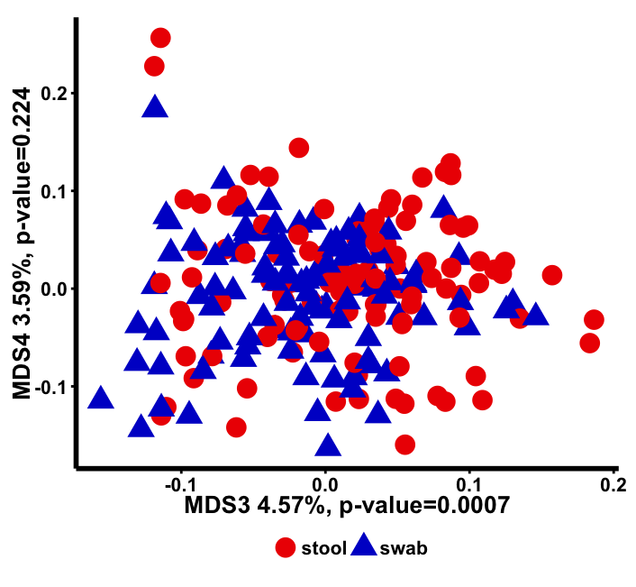

A

C

B

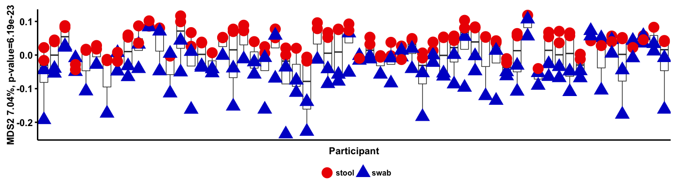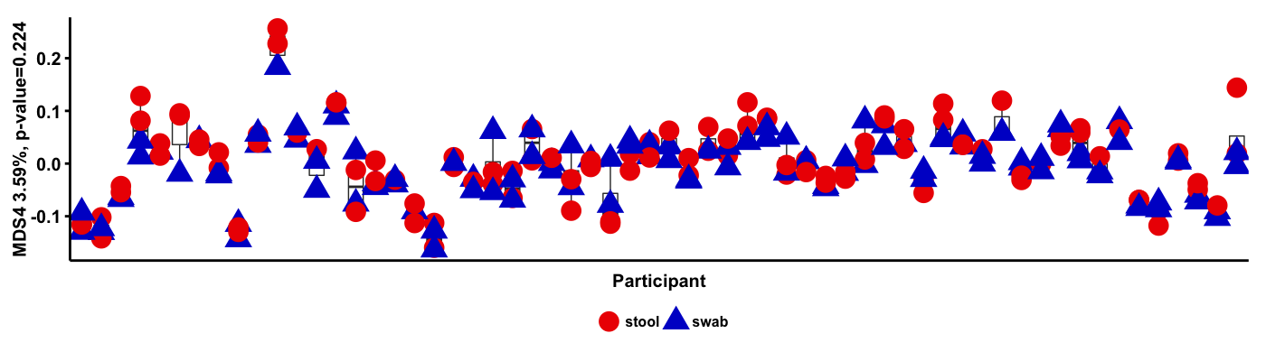

D

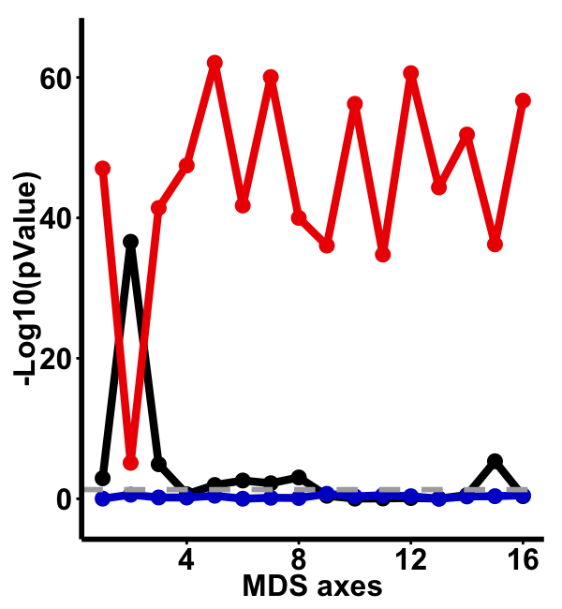

**Figure** . The first 16 axes of MDS at OTU level (open-reference) were regressed against sample type (swab or stool), participant ID and time point.